Saskatchewan College of
Respiratory Therapists
Annual Report 2019-2020

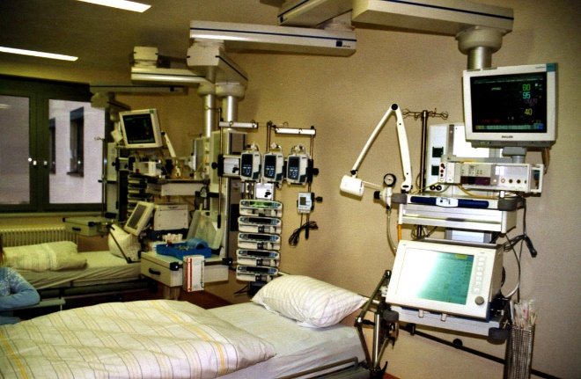

Table of Contents

page
Who we are……………………………………………………………… 3
2019-2020 Council and Staff……………………………………… 4
Reports
President and Executive Director/Registrar…………. 5
Public Representatives……………………………………. 9
Professional Conduct Committee……………………… 10
Discipline Committee………………………………………. 11
Continuing Education Committee……………………… 12
Registration Committee…………………………………… 14
Policy and Bylaw Committee……………………………… 15
2019 AGM and Education Conference Committee… 16
Provincial Summary………………………………………………….. 18
Membership Data……………………………………………………… 20
Income/Expenses……………………………………………………… 23
Financial Review……………………………………………………….. 25

Who We Are

SCRT Mission Statement
The Saskatchewan College of Respiratory Therapists exists to ensure that the public receives safe, competent and, ethical care by a regulated and continually advancing Profession.

The Saskatchewan College of Respiratory Therapists was established in 2009 with the reading of
The Respiratory Therapy Act.
As a self- regulated profession, respiratory therapists understand that it is ultimately in the best interest of the SCRT to put the interest of the public first.
As a regulatory body there are basically four things we must do; we must ensure that only competent and ethical professionals are allowed to practice, and we must ensure these people maintain their competence and ensure their practice minimizes risk to the public. We must be prepared to deal with members that fail to live up to the expected standards of the profession and, we must ensure the public maintains confidence in the regulation of the profession.
We exist to mitigate the risks posed to the public and users of the of the professional service stemming from our practice of the profession.
Our ultimate responsibility is to protect the public from the potential harm that could result from improper, or unethical practice, by unqualified individuals.

SCRT Vision Statement
Saskatchewan residents have access to excellence and continuity in the standard of care for safe, evolving, and expanding respiratory service

SCRT Values
Respect, integrity, fairness, accountability collaboration, and professionalism

2019- 2020 SCRT Council and Staff

Committees
Professional Conduct Committee Discipline Committee
Scott Downey RRT, Interim Chair Scott McCrae RRT, Chair
Phil Benson, Public Representative Bob Friedrich, Public Representative
Chris Grant RRT Karla Martin RRT
Sheldon Hrynowetsky RRT Candi Thompson RRT
Melissa Schmidt RRT Andrea Dutchak RRT
Dominique Losier RRT
Policy and Bylaw Committee Continuing Education Committee
Amy Reid RRT, Chair Shelly Filippi RRT, Chair
Nicole Hanson RRT Teresa Wasend RRT
Thomas Anderson RRT Kristin Underhill RRT
Laurie Kubik RRT
Registration Committee Merle Natyshak RRT
Sheldon Fizzard RRT, Chair
Jordan Konya RRT
Sydney Husdal RRT
Government Public Representatives
Robert Friedrich…… Appointed 2017
Philip Benson………. Appointed 2018
Betty Hoffart ………..Appointed 2019
Staff
Win Haines………….ED/Registrar
Meegan Russell …..Office Ass’t(since 01/20)
Ardis Monarchi….. Office Ass’t (until 12/19)

Council Members
President………………………………………………….Matt Harrison RRT (as of 09/2019)
Past President…………………………………………. Michelle Holodniuk RRT (as of 09/2019)
Secretary………………………………………………… Erica Elliot RRT (as 09/2019)
Treasurer………………………………………………… Anil Sarkar RRT (as of 09/ 2016)
Councilor at large for the South………………….. Mark Murray RRT (as of 09/ 2018)
Councilor at large for the North………………….. Krystal Puetz RRT (as of 09/2019)
council

SCRT President /
Executive Dirctor/Registrar

2019-2020 Report

Matthew Harrison RRT Council President
Win Haines RT(NP) ED/Registrar
The Respiratory therapists Act section 47 states: “The college shall file an annual report with the minister in the form with the contents and in the time prescribed by the Minister. This report from the President and Executive Director / Registrar along with all accompanying reports and documents are presented in order to fulfill this requirement.
As this report is being written during the summer of 2020 for the college’s fiscal year April 1, 2019- March 31, 2020, we are more than 6 months into the COVID-19 pandemic. It will seem odd to have so little mention of it as it is currently without a doubt, the dominating event not only in our personal lives but, as respiratory therapists in our professional lives as well.
The first case in Canada was reported in early January and by mid-March (March 12) Saskatchewan had its first presumptive case. A provincial state of emergency was called on March 18 and non-essential business and school closures followed within days. By this time, the SCRT office was closed to the public and all businesses were encouraging their employees to work from home if possible. The SCRT drafted an amendment to its Regulatory Bylaws (at the government’s direction) as one of 8 professions deemed essential, to ensure we had an emergency licensure classification defined. That work would be completed and subsequently approved by the Government in April. The accompanying policy and application form were also developed. In addition, in consultation with the SCRT Education Conference planning committee, the decision was made on March 30th to cancel the conference planned for September and to postpone the AGM. The hotel venue, speakers and sponsors that had been confirmed were quickly notified. This information was able to be realized in the draft budget for 2020-21. Finally, the Continuing Education Committee made the recommendation in March that the annual audit that was to have letters go out to 5% of members on May 1st be postponed. This recommendation was later approved by Council in April.
The work to prepare for a worst case scenario was just beginning at hospitals throughout the province with Respiratory Therapists being called upon for their expertise in many aspects of planning, from equipment procurement to additional training for all non-front line RTs and other health care providers.
Before these events, it was basically business as usual for the council, with a lot of work having been accomplished in 2019-20.
During the spring of 2019 council took on the task to basically rewrite the Administrative Bylaws primarily to add in information on the role and responsibilities of the ED/Registrar which hadn’t existed at the time the original Administrative Bylaws were drafted in 2009 and, to better define council positions, which were also changed to 3 year terms. The goal was to present the resolution to the membership at the 2019 AGM. In addition, all mentions of fees were removed, and a separate Fees Bylaw was drafted. This work followed that of the previous year when the Regulatory Bylaws had been thoroughly reviewed and an amendment package presented to members at the 2018 AGM.
Council also took on the task of writing a single common model Terms of Reference for all its committees, many of which have never had any written and, continued work on the complaints process documents the Policy and Bylaw Committee had presented to them in a first draft. The April meeting started with a morning session to build on the work done at the original Strategic Planning session held the year before. Council was aware the three overarching goals that had been identified needed to be broken down into manageable projects even smaller than the five basic ones identified in the first session, in order to build towards their ultimate achievement.
Of the five (5) basic Learning and Growth items identified in the initial plan, the decision was made to focus on two of them; 1. improve engagement of respiratory therapists in the college and, 2. improve understanding of the role of SCRT among respiratory therapists. With these achieved we felt we would then be able to work on the third; 3. develop a resource that describes respiratory care contacts across Saskatchewan.
Among the projects suggested were; a planned presentation on the role of the SCRT at the next education day, plans for activities to be held during RT week and, an article for the newsletter with an interview of a current council member. Work would also be started on the development of information packages and job specific nomination forms for seats on council, a handbook for council and committee members, and education opportunities searched out for council with the goal of improving their understanding of board governance. Finally, an improved orientation information package for new members would be investigated and, and a survey was to be developed in order to gather information on members’ current understanding of the role of the SCRT.
Although many manageable goals were identified at that session, there is no doubt unplanned events (the pandemic) have played a role in delaying their roll out. At this point, many of these projects have been started, but much of this this work still needs to be completed and shared with the members. An ED taskforce has been suggested to move some of these projects forward in the future.
Over the summer, work continued on the Administrative Bylaw rewrite and the new Fees Bylaw which were both approved by council at their July meeting. The Fees Bylaw was proposing a $100 increase in annual licensing fees primarily to cover the costs of changing to having a PPT, 3 day/week ED/Registrar position. The need for this position has been realized over the tenure of the current ED/Registrar if the SCRT wants to continue to properly fulfill its mandate to serve and protect the public and regulate the profession. At the fall AGM in September, after some tough questions and conversations from those in attendance, both the Administrative Bylaw package, and the new Fees Bylaw were approved.
The AGM saw Matthew Harrison transition from president-elect to the president’s role and, Michelle Holodniuk move to past president. Elections were held that saw a new councilor at large for the north, Krystal Puetz, and Secretary, Erica Elliot acclaimed as no further names were put forward for either position. We also gave our thanks to Kristina McCrae and Adele Sirois for their years on council. In the future, with more information to go out to members, the goal will be to have contested elections for what should be seen as coveted seats on the SCRT council. Membership involvement at the council level is widely recognized as a sign of an engaged membership in ensuring the mandate of public protection is upheld. A new government appointed public representative was also introduced and we were happy to welcome Betty Hoffert to the council table with her past experience with other health regulated profession councils.
The 2019 AGM also marked the 10th year since the reading of the Respiratory Therapy Act which granted the profession the right and responsibility of self-regulation. Mark Herzog gave a wonderful talk and, spoke not only of how far we have come, but also of the work ahead of us.
At the first fall council meeting a new model for meetings was presented by the council president; the meetings would be a full 6 hours in length with the morning session dedicated to council education as outlined in the Governance policies and, the afternoon session to deal with college business that requires council’s attention. After attending their own governance training session in September sponsored by NIRO, the president and ED/Registrar recognize the importance of ensuring the governance policies adopted in 2016 receive wider acknowledgment and understanding by the full council. More training opportunities for council members will be taken when they arise. A formal budget line has been added to recognize their importance and cover these costs. The meeting also saw the adoption of the new document review calendar that will ensure all reference documents of the SCRT will be reviewed in a timely manner by council or its committees, and the use of a new consent agenda format that will ensure council focuses on the work of governance, and not the business that committees are delegated to handle. Finally, further work was completed on the terms of reference for the SCRT’s 5 committees that were sent out for review and feedback to each committee.
Our January winter meeting started with an education session for council presented by the Saskatchewan College of Paramedics’ ED/Registrar, Jaquie Messer Lepage someone well versed in the Regulatory College business. She gave a very well received session on the role and importance of the legislated committees; the Professional Conduct Committee and the Discipline Committee. The meeting itself completed the major work required by council on the complaints process documents, a major undertaking that has been years in the making. The responsibility for a self-regulated profession to deal with complaints of professional misconduct or professional incompetence that are filed against a member, is one of the pillars upon which self- regulation is based. Who understands the standard of care and ethical delivery of care that is expected from a respiratory therapist better than another respiratory therapist?
Historically, the Professional Conduct and Discipline Committees relied on a simple set of instructions and documents drawn up by our legal counsel at the time the profession became self-regulated. It has long been recognized that more detail was needed in order for both committees to be able to do their mandated jobs more accurately.
With the work completed there is now a detailed procedure, along with six new polices and, a series of 14 forms that are to be referred to as standard letters and documents for use throughout the process of handling a complaint from initial filing through to a disciplinary hearing if one is required. The first of the forms is a new checklist and timetable with expectations of the delivery of the steps in processing a complaint. With this work completed the public of Saskatchewan can have the assurance the SCRT better understands their responsibility to deal with complaints in a responsible, professional and timely manner.
Two further projects were completed this year that speak to the SCRT’s legislated mandate; with the delegated function to ensure all applicants to the SCRT come from an accredited/council approved program, the SCRT was a signatory to the contract the National Alliance of Respiratory Therapy Regulatory Bodies (NARTRB) signed with a new accreditation provider following the dissolution of CoARTE, the former accrediting body. Without an education program in the province, the SCRT relies on the performance of programs in other provinces to deliver a competent entry to practice therapist. With a new nationally recognized accreditation provider, the SCRT has the confidence all programs will be fully scrutinized in all required aspects of their programs, before receiving their accredited status.
The second project in which the SCRT was a partner speaks to the SCRT’s stated object to “regulate the practice of the profession”. This year saw the development and approval of the SCRT’s first Respiratory Therapy Special Protocol. The document outlines the process an RT working in primary care must complete and demonstrate in order to be able to deliver vaccines and be prepared to treat a resultant potential anaphylactic reaction. One of the tasks this sub-group of RTs that work in the community doing home visits to patients with severe COPD can now do is administer those clients their seasonal flu vaccines. The ED/Registrar gave a presentation on the competencies and learning expected of an entry level therapist which easily demonstrated, with the core knowledge RTs have, they are well prepared, with additional training, to take on this task. This work could not have been accomplished without the assistance of the PHC Clinical Integration Unit, Population Health Managers and MHO Population and Public Health Regina area staff.
With these documents drawn up, the standard has been set for other such advanced practice special protocols the College must look to have developed in the future. In Saskatchewan, the profession of Respiratory Therapy does not have a defined scope of practice as some do. Rather, we are a profession with a defined entry to practice competency level which is then built upon depending on the chosen area of specialization and further training and certifications. It is understood by the college, regulation of these matters is a core principle of professional self-regulation in order to ensure the public interest and safety remains forefront in our duties.
The College is also very pleased to acknowledge the new fiscal year will bring the expansion of services to two hospitals in the province; the 91 bed Cypress Regional Hospital in Swift current has received funding to begin the delivery of a respiratory services program there. With a 24 hour emergency department, a busy OR and, ICU as well as being the “flagship for Acute Care in the Cypress Health Region,” the addition of the services and skill set respiratory therapists can bring to the hospital will be very welcome. Secondly, the Victoria Hospital in Prince Albert has received funding to enable it to provide services 24 hours /day, 7 days a week, with their staffing increased to a full seven respiratory therapist positions.
We believe these departmental expansions speak to a greater understanding and appreciation for the role and skill set respiratory therapists can bring to our rural hospitals in particular. With these two expansions we look to them to serve as the model for more of our rural hospitals that currently function without respiratory therapists to deliver respiratory care, something to strive for in the best interest of their clients. We look forward to the continued growth of respiratory therapy services throughout the province.
With this summary of the work completed by council this past year it can be recognized that major steps have been taken to ensure council understands their role and responsibilities to the public of Saskatchewan which includes an improved understanding of board governance. There has also been an increased understanding and positive steps taken in the role of the college to the public of Saskatchewan in ensuring the mandate to serve and protect the public and to regulate the profession, are upheld.

Respectfully submitted,
Matthew Harrison RRT, President of SCRT Council
Win Haines RT (NP), SCRT ED/Registrar

SCRT Public Representatives

2019-2020 Report

Robert Friedrich
Phillip Benson
Betty Hoffart
The Respiratory Therapist Act section 9(1) states the Lieutenant governor in council may appoint three persons who reside in Saskatchewan as members of the council. And further, section 5a states members of the council appointed pursuant to this section may exercise rights and serve as a member of committees to the extent as other members of the council.
SCRT has three public health members appointed by the Province of Saskatchewan to represent the interests of the people of Saskatchewan. These members sit on various committees of SCRT including the Professional Conduct and Disciplinary Committee.
In the past year both the Public Health Representatives and SCRT have worked together to develop a mutually supportive relationship meeting the needs and interests of the citizens of Saskatchewan.
We look forward to furthering this relationship on all levels confident that both will enjoy continued success.
Respectfully submitted,
Bob Friedrich

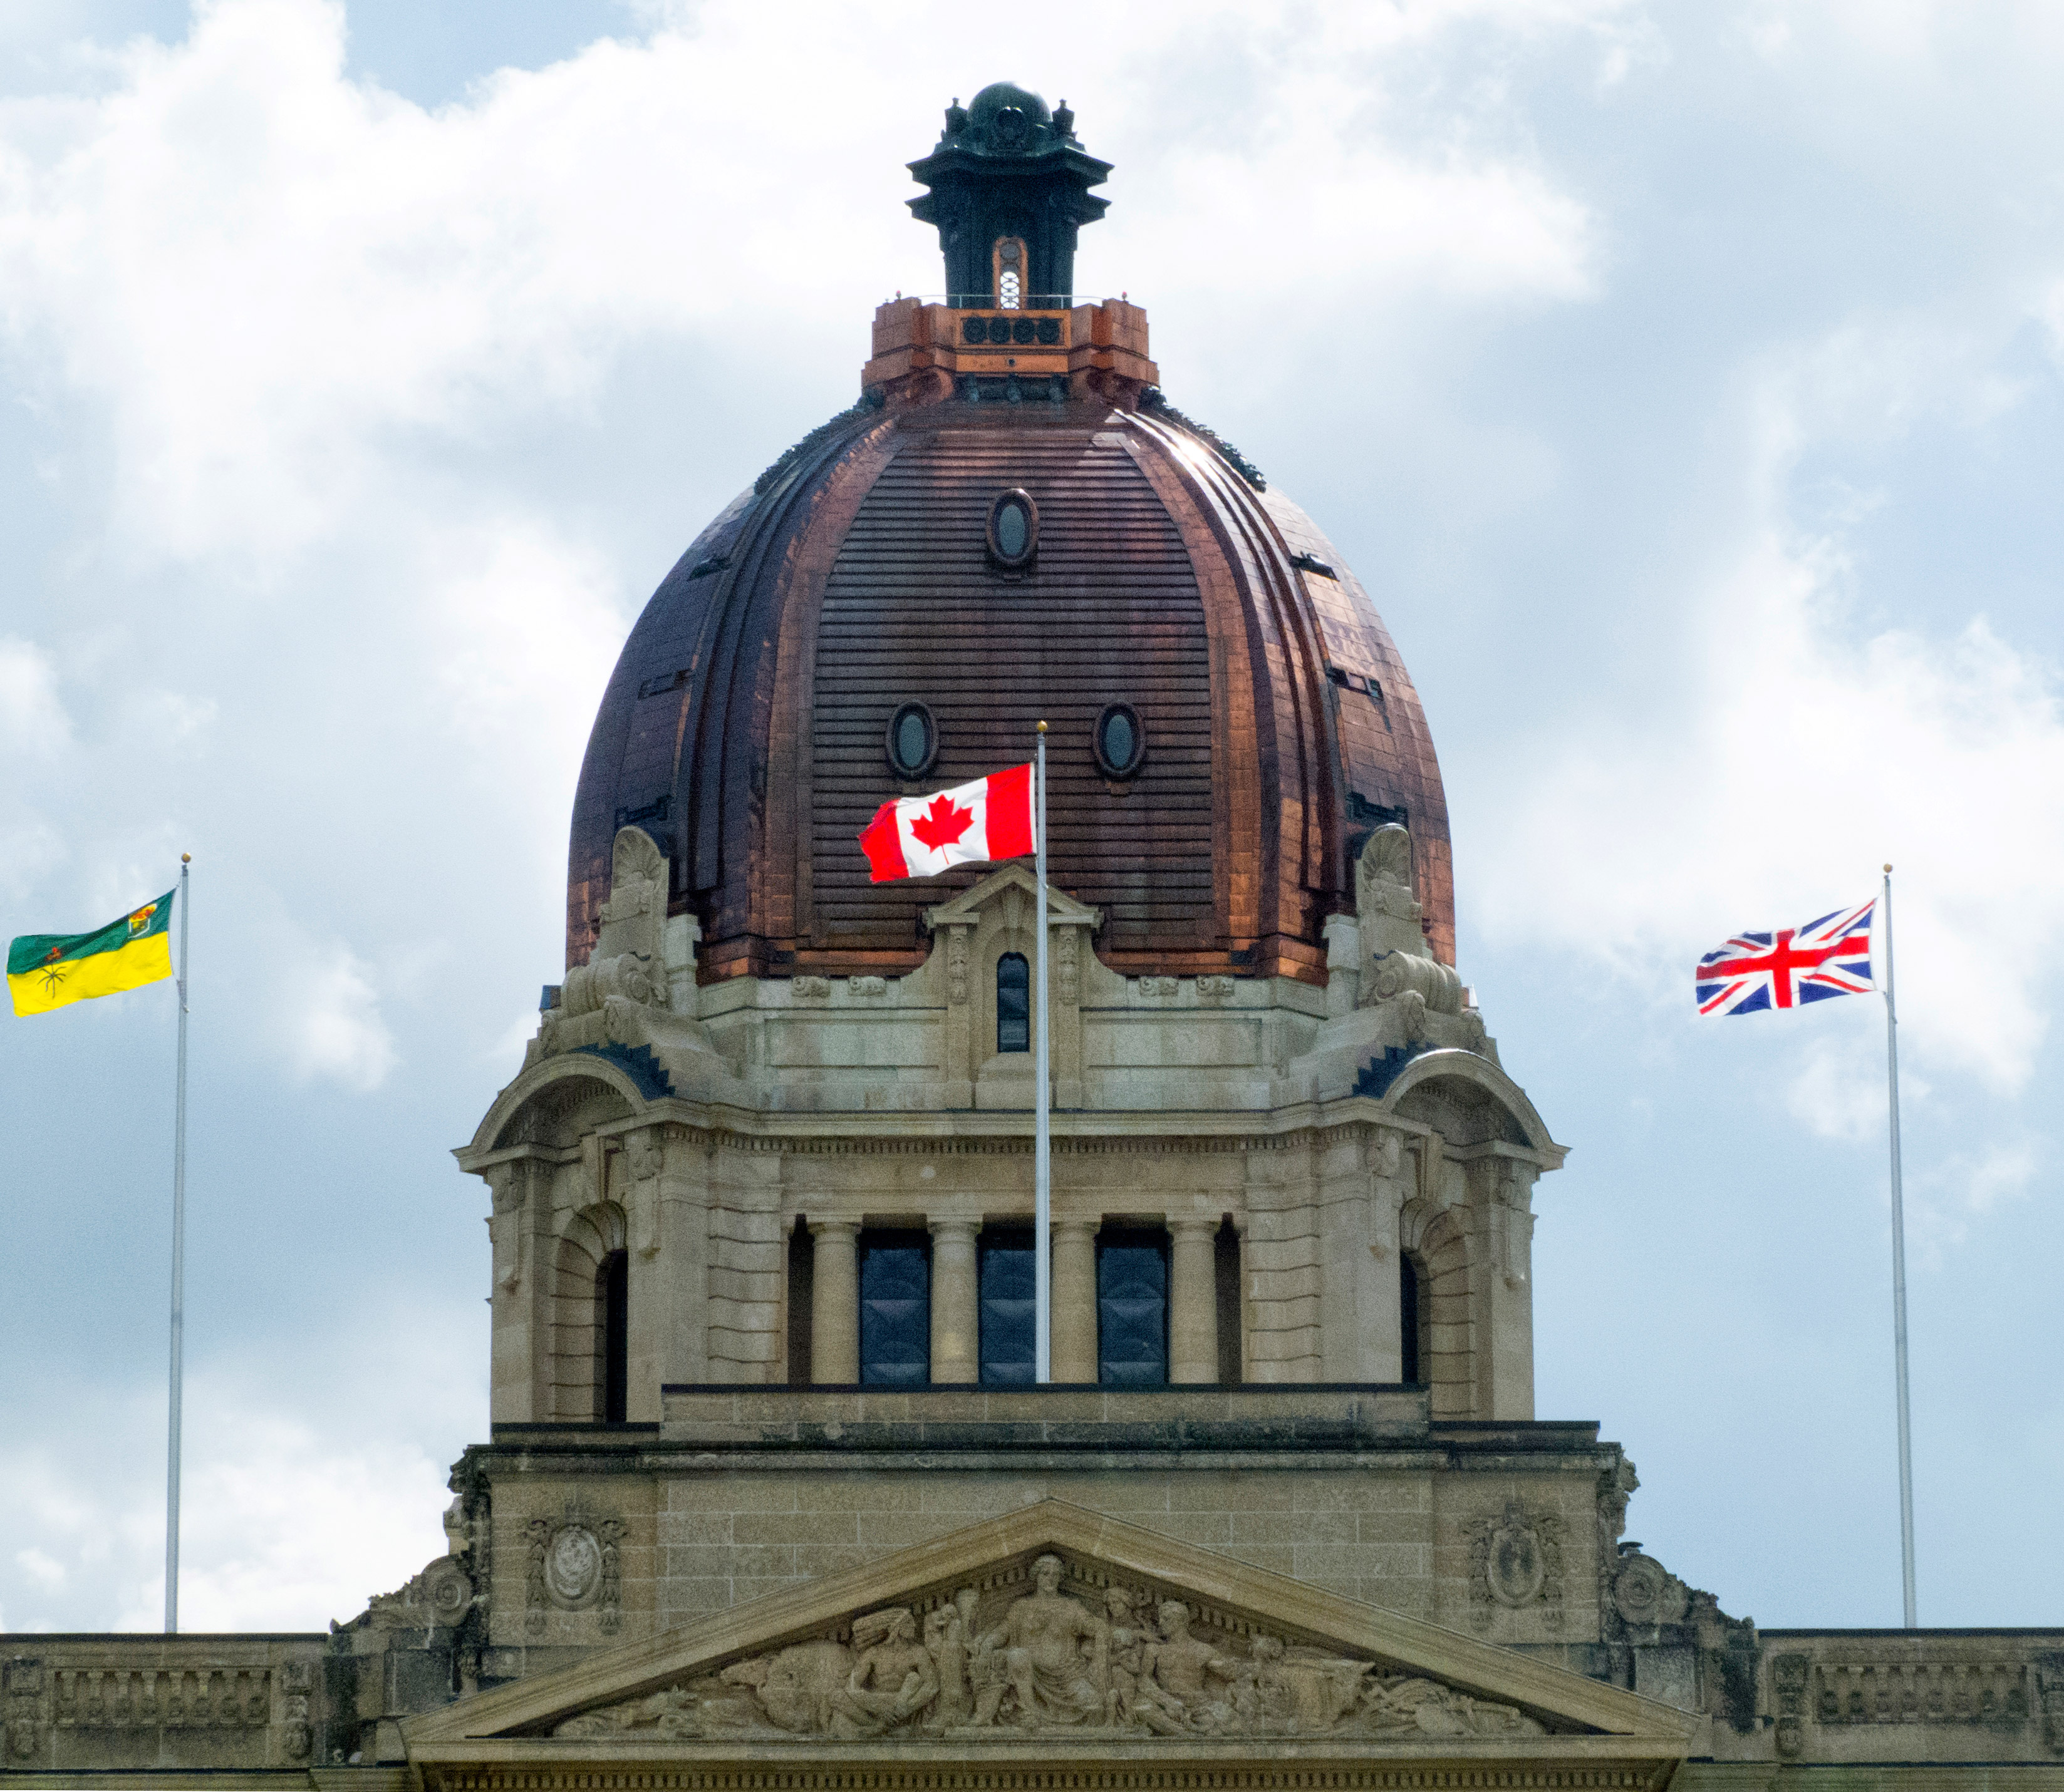

SCRT Professional Conduct Committee

2019-2020 Report

Scott Downey RRT Regina, Interim chair
Phil Benson Public Representative
Chris Grant RRT, Saskatoon
Sheldon Hrynowetsky RRT, Regina
Dominique Losier RRT, Saskatoon
Melissa Schmidt RRT, Regina

The PCC is a statutory committee and is mandated to ensure protection of the public interest by, reviewing and investigating any and all complaints it receives either directly, or from council, alleging that a member is guilty of professional misconduct or professional incompetence.
The PCC received a total of 3 new cases between April 1, 2019 and March 31, 2020; (case #’s 32, 33, 34). One was filed by an employer, one by the ED/Registrar on behalf of the Continuing Education Committee and, one from a member of the public.
Two of these have been settled with an alternate dispute resolution (ADR) agreement for which final parameters are in the process of being drafted. The third is still in the investigative stage with an anticipated completion date within a couple of months.
In addition, 2 cases from 2018-19 were completed:
One was settled with an alternate dispute resolution (ADR) that included a mentoring period and fine payment, the second was unable to be settled with an ADR and was referred to the Disciplinary Committee of the SCRT for a hearing which was held in April of 2019. The decision came down in September with the PCC subsequently asked to submit information to the penalty hearing held in December 2019, which resulted in a penalty decision being brought down in February of 2020.
In other business of the committee, the previous chair T. Tessier stepped down in January and Scott Downey, the former chair, agreed to step into the chair position for an interim period of a year until a new chair can be appointed.
The PCC had the opportunity to work with a professional investigator over a four month period from June – September 2019 who acted in a mentoring role to the committee. Lots of take-aways on process improvements were the result for the committee.
Finally, the PCC realized they cannot have one of the government appointed Public Representatives on council as per The Act section 25(2) and will ask council to recruit an independently contracted Public Representative in order to keep the public’s voice on the committee.
Respectfully Submitted,
Scott Downey, RRT Chair

SCRT Discipline Committee

2019-2020 Report

Scott McCrea RRT, Saskatoon Chair
Robert Friedrich Public Representative
Andre Dutchak RRT, Melville
Karla Martin RRT, Regina
Candi Thompson RRT, Saskatoon
The Discipline Committee (DC) is a statutory committee and is mandated to ensure protection of the public by establishing and maintaining a framework for dealing with matters referred to it for discipline by the Professional Conduct Committee (PCC).
Upon receiving a report from the SCRT PCC, the Discipline Committee is to hold a disciplinary hearing to hear and determine a formal complaint [The Act section 29(1])
The DC shall follow all regulations as laid out in The Respiratory Therapists Act in holding the hearing.

The Discipline committee held its first hearing in 2019, it was a new experience for all members and in fact the first for the SCRT. There were a lot of learrnings and take-aways from the experience and they will be considered for future hearings. Some of the business of the hearing was completed via conference call while the actual decision meeting took place face to face in Davidson with our legal counsel, in order to allow for a complete discussion. The case ended with a ‘guilty of professional misconduct’ verdict for the member. Full details of the case, the decision and the penalty may be found on the College website. (scrt.ca)
The DC continued to meet via conference call and review cases from other colleges as an opportunity for learning and discussion. These reviews have brought up thoughts that will need to be looked at by the committee and possibly legal counsel for the committee, in order to gain some clarity.
The Chair and members reveiwed and provided feedback for the Terms of Reference for the committee. Members continue to attend education opportunities such as Tribunal training or other courses to benefit the committee and its members.
The committee welcomed a new member, Andrea Dutchak and said good bye to Angela Barsalou and thanked her for all her work with the committee.
Respectfully submitted,
Scott McCrea RRT, Chair

SCRT Continuing Education Committee
2019-2020 report

Shelly Filippi RRT, Regina Chair
Laurie Kubick RRT, Saskatoon
Merle Natyshak RRT, Regina
Kristin Underhill RRT, Moose Jaw
Teresa Wasend RRT Saskatoon

It is a requirement of licensure that Registered Respiratory Therapists in Saskatchewan participate in continuing education. The mandate of the Continuing Education Committee (CEC) is to provide recommendations to the Executive Director / Registrar of the SCRT regarding the Continuing Education Policy & Program. The CEC also assists the ED/ Registrar in the annual education audit. The members of this committee recognize that advancing technology and increasing responsibility requires therapists to continually update their knowledge and skills. Continuing education ensures professional competence and prevents professional obsolescence.

Five percent of the eligible membership is audited each year for the previous two year audit period. For the 2017-2019 audit period nine members were audited. All ultimately passed, meeting the audit requirements as set in the SCRT Policy & Procedure. The audit was performed June 17, 2019 at Saskatoon City Hospital. At the time, one audited member hadn’t submitted a package. It was a long process of several months of poor communication and ongoing failure to submit the required educational material that resulted in the file finally being forwarded to the PCC. This is the second year this CEC has had an audited member not submit the required information by the deadline, which is 30 days after signing for the registered letter notifying them of the audit. A new fees bylaw was approved at the AGM in September which looks to address this, as it imposes a $50/ week penalty, or any portion thereof, until the audit package is received at the SCRT office.

After completing the review of the submitted audit documents the CEC had its annual meeting. At this meeting the audit process was reviewed, including a review and discussion of the CEC Policy & Procedure and the CEC Package (handbook) that is sent to each member with the notice of audit. The documents were reviewed for wording, clarity of language and any needed improvements that could be implemented to make the audit process more efficient and effective for both those being audited and the work of the committee.

All committee members were required to sign and submit a confidentiality and non-disclourse agreement. Work has been ongoing regarding new Terms of Reference for non- legislated committees including Purpose/Responsibilities and membership on these committees and their organization.

We were sad to see Angela Barsalou leave our committee in February 2019. Her professionalism and leadership are greatly missed. The CEC welcomed new member Merle Natyshak from Regina to the committee.

Due to the COVID 19 crisis the SCRT decided on March 21/20 to postpone both the notification that goes out to members and the actual audit for 2018-2020 until, as one of the core professions on the front line in the pandemic there was a chance to gain a better understanding of the impact this pandemic will have on our lives, both personal and professional.

We are happy to report we continue to gain a lot of valuable experience and knowledge as a committee and believe we will be able to apply this going forward to serve in our role on the CEC.

Respectfully submitted,

Shelly Filippi RRT, Chair

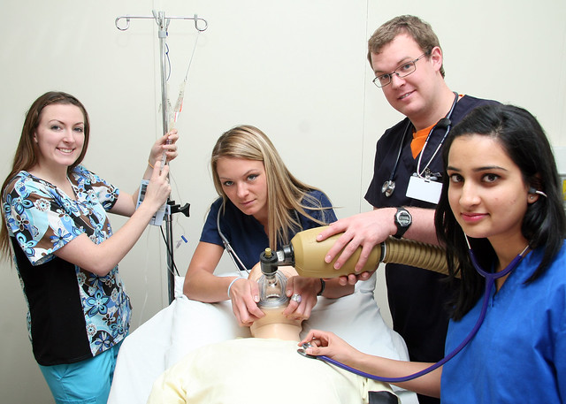

SCRT Registration Committee

2019-2020 Report

Sheldon Fizzard RRT, Regina Chair
Jordan Konya RRT, Regina
Sydney Husdal RRT, Regina
The Respiratory Therapists Act 2009 section 13(1) states; the council may establish any committees that are provided for by the bylaws or that it considers necessary. The Registration Committee will assess the details of an applicant or member’s education, experience, practice or other qualifications as required, that demonstrate the competence mandated for membership/licensure in accordance with The Act, bylaws, and applicable policies, and will subsequently provide a recommended outcome to council for applicant/member cases sent to them; i.e. licensure, licensure with conditions, licensure if further training is completed, no licensure.
The Registration Committee met on three separate occasions over the last year; two in-person and one conference call.
Work completed by the committee includes;
- two draft copies of proposed Terms of Reference were submitted to the council.
- Committee Orientation package developed.
- two applications for membership / licensure were received and reviewed with recommendations sent to the council.
Committee members read The Imperfect Board Member for continuing education

Respectfully Submitted,
Sheldon Fizzard RRT, Chair

SCRT Policy and Bylaw Committee

2019-2020 Report

Amy Reid RRT, FCSRT, CRE, Regina Chair
Thomas Anderson RRT, Regina
Nicole Hanson-Bailey RRT, Regina
The Respiratory Therapists Act 2009 section 13(1) states; the council may establish any committees that are provided for by the bylaws or that it considers necessary.
The Policy and Bylaw Committee was created and established in January 2019 with the purpose of providing support to the college and council by; assisting in mandated regular reviews and subsequent identified needed revisions of bylaws and policies. In addition, they will draft, review, and recommend new or existing required policy and bylaws and, ensure all new recommended bylaws and policies have been reviewed for clarity of purpose, transparency, objectivity, and are impartial and fair while being compliant with The Act.
For the period of April 1, 2019 to March 31, 2020 the Committee met quarterly to work on and finalize documents relating to the complaints process and the workflow that stems from that. The list of completed documents includes: Complaints Process (Policy and the Procedure), Investigation Process, Confidentiality of Investigation Report, Discipline Hearings, Discipline Orders, Appeal of Discipline Decisions, Terms of Reference, Timeline/Checklist, and Form Letters.
Our first year was quite a success and as a newly formed committee we learned quite a bit and look forward to applying that knowledge to all future tasks.
Moving forward, we have started to review documents relating to the topics of Conflict of Interest and Confidentiality. We hope to create two information documents (one on conflict of interest and the other on confidentiality), and then two agreements to be signed by council and committee members (updating the confidentiality agreement and creating a conflict of interest form). We hope to have these completed by July 1, 2020.
Respectfully Submitted,
Amy Reid RRT, FCSRT, CRE, Chair

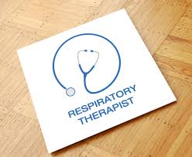

2019 Saskatchewan Respiratory Education Conference & AGM Report

Casey Hummeny RRT, Saskatoon Chair
Kristina Vargo RRT, Saskatoon
Kirsti Gingras RRT, Saskatoon
Krystal Puet, RRT, Saskatoon
Deb Grey RRT, Moose Jaw
Student Volunteers
Hannah Pattison S’toon (NAIT)
Rebecca Chery S’toon (SAIT)

The 2019 Saskatchewan Respiratory Education Conference was held at the new Saskatoon Holiday Inn Express and Suites and was a smashing success! We had 43 respiratory therapists in attendance this year at the SCRT annual general meeting and 114 attended the education conference portion the following day, including 57 RTs and many vendors and their representatives . We were also thrilled to have two RN’s in attendance this year. We were particularly pleased with the turnout and noted many speakers and industry partners stayed around to listen to other speakers’ talks and mingle with our members. The committee received overwhelmingly positive feedback for all conference events, including speakers, industry presence, venue, food, and social activities.
An event like this is not possible without the support we receive from our volunteers, industry partners and speakers! Our industry partners were set up throughout the conference at individual booths for attendees to get first-hand knowledge and learning on new equipment, as well as up and coming therapies. This also provides valuable networking opportunities with RTs from other centers within our province.
Our speakers and topics were well received this year and brought an exceptional amount of knowledge, insight and motivation to our conference. We were fortunate to bring in speakers from across the country as well as local ones. Pam August was our keynote speaker - she was incredibly motivating and spoke very well about connecting potential throughout our lives and in our workplaces. Carolyn McCoy, from the Canadian Society of Respiratory Therapists, travelled from the Maritimes to speak to us about emerging roles in Respiratory Therapy and how far our profession has come. We learned about the new ALS clinic in our province, being led by Dr. Kerri Schellenberg, and the role that RTs are playing in its success. We also heard from Dr. Darryl Adamko on childhood asthma and how we may see it present in the various areas RTs work in. We were extremely fortunate to have Brian Starkell join us from the Nipawin Fire Department to share his experience following the devastating Humboldt Broncos bus crash in 2018. We were all deeply touched by his personal account of that night and the days and months following and, appreciated his coming to share it with us. Tyler Pope, an RN and educator in Saskatoon, later spoke to us about Critical Incident Stress Management and its emerging role in our profession and how vital a program such as this is to frontline workers such as Respiratory Therapists. One of the Saskatoon neonatologists, Dr. Lannae Strueby, informed us on her fascinating bronchopulmonary dysplasia research and the clinical implications of her findings in the neonatal world. We ended the day with a personal account of life after polio. Anna Falkingham joined us to tell her story of living with post-polio syndrome and how RTs have helped her throughout this difficult and ever-changing journey.

Following the conference, our committee met with next year’s 2020 planning committee to review some of this year’s feedback. We are very much looking forward to the next education conference -- whenever COVID-19 lets us have it!
Respectfully submitted,
Casey Humeny RRT, chair

SCRT PROVINCIAL REPORT

2019-2020

With Contributions from:
Barbara Hewitt, Sr. RRT Victoria Hospital, Prince Albert
Amy Reid, RRT, FCSRT, CRE Clinical Integration, Regina
Mark Herzog, BAdmin, RRT, Manager, Regina
Deb Grey, Sr. RRT Moose Jaw
Lyndsay Rindero Sr. RRT N. Battleford
Mary Kate McLaughlin Sr. RRT, Lloydminister
Jill Stevenson BScPT, Therapies Manager Swift current
Lisa Martin RRT, Manager, Saskatoon

With a look back at the provision of Respiratory Services in the province for 2019-20 it can be seen there has been a lot of growth or, preparation for service expansion in the coming fiscal year, 2020-21.
With a new department that came on line in April 2020 in Swift Current, to expanded staffing coverage in Prince Albert with an anticipated new nursery, Lloydminster with more coverage expected, as well as new positions in Regina, the continued growth of the new Jim Pattison Pediatric hospital in Saskatoon, this will give the province 8 centres with Respiratory Services (Regina, Saskatoon, Moose Jaw, Prince Albert, Yorkton, Lloydminster, North Battleford and Swift Current).
Overall, the impact of the COVID-19 pandemic hit all the hospitals with Respiratory Services, whether designated as a COVID centre or not. All centres basically suspended diagnostic and assessment work, (sleep testing, pulmonary function testing and outpatient services) other than urgent cases and prepared for a potential surge of COVID patients. The work to co-ordinate the needed province wide response took a lot of time and energy with the development of systems and protocols that will continue to serve the province well into the future, even when the public health emergency is declared over.
Another area of growth that has been realized is in the primary care role in Regina, expanding to add 3 more FT RT positions in addition to 2 LPN positions in the acute care hospitals to assist with transition to community and the home RT programming available.
The RTs in primary care have an ever expanding role including; spirometry, COPD education, routine home visits, phone visits, immunizations (flu and pneumo), routine trach changes, home ventilator visits and maintenance, smoking cessation support, COPD rehab programming and maintenance exercise. They also oversaw the distribution of approximately 50 spirometry kits around the province and are co-ordinating the needed education for the centres that received them.
Finally, with the onset of COVID -19 in mid March all Primary Care staff under Chronic Disease were redeployed to the COVID testing site or the COVID assessment centre.
North Battleford, Lloydminster and Moose Jaw all saw their departments fall under new mangers and had new therapists added to the team after either staff departures or the need for maternity leave coverage, thereby maintaining or increasing their staffing levels, which still presents challenges to delivering service 24/7. North Battleford provided a lot of education to nursing and therapy staff in order to have them assist in trach care and care of long term ventilated patients. Similarly, Lloydminster’s focus with their service expansion was in the area of community services. Both Lloyd and Battleford are looking forward to the delivery of new pulmonary function equipment in the coming year which will have them able to provide enhanced testing to clients in their area.
Regina started the work to have 2 new positions created with unique responsibilities; one dedicated to pediatrics in the Children and Maternal Health portfolio and one specifically to assist with bronchoscopies and, on alternate days to oversee discharge planning for long term patients to home or Wascana Rehab Hospital. In addition, Regina personnel are part of the provincial team developing the RFP to set the guidelines for PF equipment purchases to ensure equipment is standardized throughout the province. Saskatoon also continues with its staff expansion, especially as it pertains to the new Jim Pattison Children’s Hospital.

This noted growth and expansion of services and, centres providing these services, is encouraging to see in light of the SCRT’s strategic plan which is to work toward the goals of, improved continuity of Respiratory Care provincially, an improved awareness of the role RTs can play in integrated health care and, an increase in the role RTs can have in health system planning. Having seen the steps taken this past year, the SCRT is encouraged and, looks forward to the expanding role and responsibilities for our members in the delivery of healthcare services for the people of Saskatchewan.

PRIMARY PRACTICE AREA
271 members

It can be seen our largest contingent of members still work in Acute Care. This description covers the primary role in acute care hospitals, whether working with adult, pediatric or neonatal populations. There is no doubt the community and rehab role is expanding, whether working for the SHA or private industry. Diagnostics (PF and sleep lab) is also making up a growing percentage of the membership followed by an operating room role and/or formal anesthetic assistant. It is also encouraging to see a growing number of therapists moving into an administration/ managerial portfolio.

AGE
271 members

A review of the age of our current membership gives a fairly balanced chart, although it generally
demonstrates Respiratory Therapy is a young person’s domain with approximately 70% being < 40 years
old.
Of this younger age contingent, a further breakdown shows 27% of full licensed members are in their 20’s
with 42% currently in their 30’s.
A review of the age of our current membership gives a fairly balanced chart, although it generally
demonstrates Respiratory Therapy is a young person’s domain with approximately 70% being < 40 years
old.
Of this younger age contingent, a further breakdown shows 27% of full licensed members are in their 20’s
with 42% currently in their 30’s.

A review of the age of our current membership gives a fairly balanced chart, although it generally
demonstrates Respiratory Therapy is a young person’s domain with approximately 70% being < 40 years
old.
Of this younger age contingent, a further breakdown shows 27% of full licensed members are in their 20’s
with 42% currently in their 30’s.

GENDER
271 members

Respiratory Therapy is still a female dominated profession in this province as the data has demonstrated consistently for the last 4 years. Approximately 70% of the SCRT full licensed membership is female.
The last time it was less than this was in 2015/16 when the female percentage was 60%.

SCRT Income / Expenses 2019-20

Expenses 2019-20

To review the Financial Statements for the fiscal year ended March 31, 2020 please open the documents below.

